

(http://sourceforge.net/projects/frinika/)

Final Report
Team member Student ID
Buthainah Aldosary 6302459
Jagdeep Singh 6449948
Luiz Mauricio Silva 6317006
Mischell Flor 5428483
Seun Odutola 6078109

Milestone 1:

Project Description
The Frinika project is an open source software under the license GNU General Public License version 2.0 (GPLv2). It is a complete music workstation aimed to musicians to record, create, adjust, add and remove effects, and mix music tracks. It is platform independent, running on Windows, Linux and Mac OS operating systems.
All team members like and are interested in music; therefore Frinika is a good software application to be worked on during this term project.
Frinika is in beta maturity stage. It was created in 2007 and is still active today, and it has three main developers.
There are professional music recording / editing commercial tools available, obviously paid. The open source community makes available to amateur musicians some good tools to aid the music creation and edition processes. Audacity is a good example, but it is written in a procedural language, which prevented it of being chosen as a project.

Project Size and Scope
Frinika contains 65,753 lines of code, 1,195 classes, and 89 interfaces, grouped in 133 packages.
This project was considered too large to be a term project; therefore the team members selected the Sequencer GUI component of it as a reasonable scope. This component contains the following packages:

# | Package | Number of  Lines of Code | Number of classes | Number of  interfaces
1 | com.frinika.sequencer.gui | 3,208 | 59 | 6
2 | com.frinika.sequencer.gui.clipboard | 372 | 9 | 0
3 | com.frinika.sequencer.gui.menu | 1,522 | 48 | 0
4 | com.frinika.sequencer.gui.menu.midi | 2,331 | 73 | 1
5 | com.frinika.sequencer.gui.mixer | 839 | 16 | 1
6 | com.frinika.sequencer.gui.partview | 2.736 | 60 | 0
7 | com.frinika.sequencer.gui.pianoroll | 2,934 | 42 | 6
8 | com.frinika.sequencer.gui.selection | 409 | 6 | 2
9 | com.frinika.sequencer.gui.tracker | 1,271 | 25 | 0
10 | com.frinika.sequencer.gui.transport | 300 | 14 | 0
11 | com.frinika.sequencer.gui.virtualkeyboard | 169 | 2 | 0
 | TOTAL | 13,358 | 354 | 16

Even though the total Lines of Code of the proposed scope is greater than the recommended 10,000, it needs to consider that the scope refers to user interface only; therefore we believe it is be simple enough for a term project.

Group Members

Buthainah Aldosary is a full-time Masters student in Software Engineering. She is comfortable with Object Oriented programming languages. She has implemented several projects in C# and Java; the latest being a Task Manager using the MVC architecture. Frinika is of interest to her, as she would like to expand her understanding of GUI development through the application of a complete music workstation.
Jagdeep Singh is a full time student in Software Engineering. He has nearly two years of experience in software development. He is quite comfortable with object oriented languages such as C++ and C#. He would like to work on Frinika and enhance his knowledge in GUI development.
Luiz Mauricio Silva is a full-time student on Master of Software Engineering at Concordia University, currently in his last term of the program. He has 13+ years of experience in Software Development, Systems Integration, Consulting and Project Management. Even though he has limited knowledge about GUI development, he is experienced in Java and has some knowledge of the music industry, as an amateur musician.
Mischell Flor is a part-time student on M. Software Engr. She is currently working as software developer. She has four years of experience in Software Testing. She knows object-oriented programming such as java, c++, and c#. In addition, she already took the course User Interface Development Tools & Technology (SOEN 6771). In this project, she can identify UI design patterns that are used in Frinika. She can also do Quality Testing in it to identify the codes that require refactoring.
Seun Odutola is a Software Engineering Master’s student with adequate years of experience in Software development. He is versed in majority of the C derivative languages including Java. Having worked in the past on musical software projects and as well as possessing a decent understanding of GUI’s development, he is comfortable working on the Frinika project and would love to seize this opportunity to enhance his repertoire.

Milestone 2

Personas, Actors, and Stakeholders

Stakeholders:
Musicians need to compose, record and mix music songs; therefore they are interested in a music sequencer such as Frinika.
Developers are responsible to construct the software with on time, on budget and with quality, thus they are interested in the software itself and its acceptance by users.
Testers are interested in the music sequencer because they are responsible to test the software, guaranteeing it is published with no critical or major errors.
Tech Support personnel are interested in the music sequencer as they are the ones who support the users in its operation.

Actors:
Musician: Musician is a human actor that interacts with the music sequencer (Frinika) to record, compose and mix music tracks and songs. They interact with Frinika by the GUI, subject of this study.

Persona:

Name: Christina  Age: 26  Occupation: Musician | 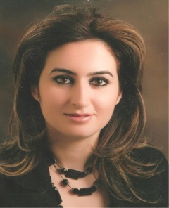
Christina is a 26 years old amateur musician. She plays piano and guitar. She likes to mix music and create impressive tracks for her friends. She edits music and makes ringtones for her cell phone and shares them with her friend. She likes to promote her music and also sell it through various online music stores. She uploads her selective tracks on YouTube, iTunes and gets complements and advises from various users including some of the renowned musicians. She has keen interest in music industry and wants to excel in her field.

She has to use several music tools and software to edit or mix her music. She would love to work on software with good sound recording and editing quality. She wants software which displays the music node graph, tracker or notation graph. This will help her with more accurate node location and will edit the track accordingly. So Christina wishes to have software with all the useful qualities and user friendly interface.

Informal Use Cases
This section describes 10 queue card length use cases.

Unique Identifier: UC-1
Name | Manage Project
Summary | This use case enables the Musician to manage projects.
Actor | Musician
Precondition | System is running.
Basic Sequence | New Project: The Musician selects the option to create a new project. The system responds by creating a new instance of an empty project.  Edit Project: Musician opens an existing project. System loads the project and presents it for edition. Musician edits the project as desired.  Save Project: Musician selects the option to save the project currently open. System saves the project.  Save Project As: Musician selects the option to save the project as a different project file. System asks for the directory and project file name and saves the project in the new location.  Close Project: Musician selects the option to close a currently open project. System verifies if there are unsaved changes and prompts for confirmation. Musician confirms and the system closes the project.
Post Condition | Project is successfully created, opened, saved, or closed

Unique Identifier: UC-2
Name | Import Music (Midi)
Summary | This use case enables the Musician to import an existing Music (midi)
Actor | Musician
Precondition | Music (midi) exists to be imported.
 | Musician selects the option to import a Music (Midi). System prompts for the Music file and imports it into a new project inside the application. Musician plays the Music and makes desired editions.
Post Condition | Music is successfully imported into the system.

Unique Identifier: UC-3
Name | Synchronize Tracks
Summary | This use case enables the Musician to synchronize (time-wise) multiple tracks inside the same Music.
Actor | Musician
Precondition | Music is open in the system.
 | Musician selects the track to be synchronized and change its start time. System displays the selected track starting from the new start time. This is repeated for all tracks that need to be synchronized.
Post Condition | All tracks within a Music have their start time synchronized to each other.

Unique Identifier: UC-4
Name | Compose Track
Summary | This use case enables the Musician to compose a new Track.
Actor | Musician
Precondition | Project is open and ready for edition.
 | Musician selects the option to create a new Track. System creates an empty Track. Musician adds notes as desired inside the new Track. Musician can also remove or change the notes added. Musician plays the Track to verify the result of the composition.
Post Condition | New Track is composed by the Musician.

Unique Identifier: UC-5
Name | Edit Track
Summary | This use case enables the Musician to edit an existing Track
Actor | Musician
Precondition | Project is opened and it contains at least one Track.
 | Musician selects an existing Track. Musician adds and deletes notes from the Track, as desired. Musician plays the Track to verify the changes.
Post Condition | Track is edited by the Musician.

Unique Identifier: UC-6
Name | Manage Notes
Summary | This use case enables the Musician to manage notes
Actor | Musician
Precondition | Project is open and it contains at least one Track.
Add Note: Musician selects the position (time-wise) to add the note. Musician selects the option to add a note. System displays the new note.
Remove Note: Musician selects an existing note. Musician selects the option to remove the note. System removes the note from the Track.
Post Condition | Notes are successfully added or removed from a Track.

Unique Identifier: UC-7
Name | Select Synthesizer
Summary | This use case enables the Musician to select a synthesizer.
Actor | Musician
Precondition | System is running.
 | Musician either creates a new project or opens an existing project. Musician selects the option to choose the synthesizer. Musician selects the desired synthesizer. If a track exists, Musician plays the Music to verify the results produced by the synthesizer.
Post Condition | Desired synthesizer is selects for a given Music.

Unique Identifier: UC-8
Name | Record Track
Summary | This use case enables the Musician to record a new track.
Actor | Musician
Precondition | Project is open.
 | Musician have an instrument that supports Midi connected to its computer. Musician selects the option to record a new track. Musician plays notes in the instrument. System captures the notes and creates the new track whilst the instrument is played. Musician selects the option to stop recording. System displays the newly recorded track.
Post Condition | New Track is successfully recorded.

Unique Identifier: UC-9
Name | Mix Music into Midi
Summary | This use case enables the Musician to mix a Music into a Midi.
Actor | Musician
Precondition | Project is open and it contains at least two tracks.
 | Musician selects the option to mix a Music into a Midi. For each track, Musician selects the desired volume level, equalization, compression, faders, gain and balance (if music is stereo). For the whole music, Musician selects the desired master volume. Musician selects the option to mix the music, and then all tracks are mixed into one Midi file.
Post Condition | Music is successfully mixed into one Midi file.

Unique Identifier: UC-10
Name | Mix Music into Audio
Summary | This use case enables the Musician to mix a music into an audio file.
Actor | Musician
Precondition | Project is open and it contains at least two tracks. Synthesizer is properly selected.
 | Musician selects the option to mix a Music into audio. For each track, Musician selects the desired volume level, equalization, compression, faders, gain and balance (if music is stereo). For the whole music, Musician selects the desired master volume. Musician selects the option to mix the music, and then all tracks are mixed into one audio file, using the pre-selected synthesizer to produce the actual sounds.
Post Condition | The System successfully displays the notation sheet.

Domain Diagram

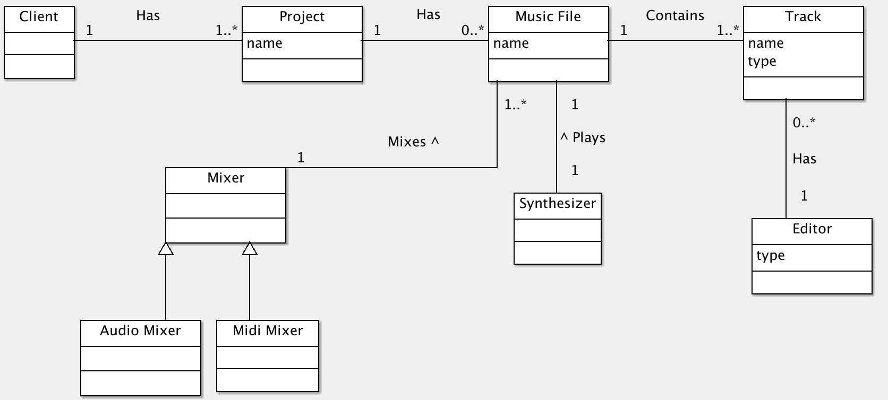

The client can create a project that can initially be empty or contains one or more music files. Each music file is composed of multiple tracks of different types (e.g. voice, piano, bass). For every track there is an editor to view and alter the tracks. A music file can be played using the synthesizer and also be mixed with other music files using the audio or midi mixer.

Fully Dressed Use Case
Fully dressed use case for manage project:

Use case UC1 - Manage Project

Name | Manage Project
Level | Summary
Primary Actor | Musician
Scope | Manage Music project
Precondition | System is running.
Success End Condition | Project is successfully created, opened, edited, saved, or closed.
Failed End Condition | Error occurred while creating new project, opening, editing, saving or closing the project.
Main Success Scenario | - New Project/Open Project: The Musician selects the option to create a new project or selects a saved project to open it. The system responds by creating a new instance of an empty project or the selected project.  - Edit Project: System loads the selected existing project or new project and presents it for edition. Musician edits the project as desired.  - Save Project: Musician selects the option to save the project currently open. System saves the project to location specified earlier or default location.  - Save Project As: Musician selects the option to save the project as a different project file. System asks for the directory and project file name and saves the project in the new location.  - Close Project: Musician selects the option to close a currently open project. System verifies if there are unsaved changes and prompts for confirmation. Musician confirms and the system closes the project.
Extensions | 1a. File format of the project selected to open is not supported by the system.  4a. File location selected to save is unauthorised to access.  4b. File name selected already exist in the destination folder.

Milestone 3

Class Diagram of Actual System
As previously defined in Milestone 1, the Sequencer GUI component of Frinika is to be evaluated. This section describes the architecture of Frinika’s GUI component, and compares it with the Domain Diagram defined in Milestone 2.
The Domain Diagram is presented in figure 1, while the actual Frinika GUI architecture is presented in figure 2.
Figure 1: Domain Diagram

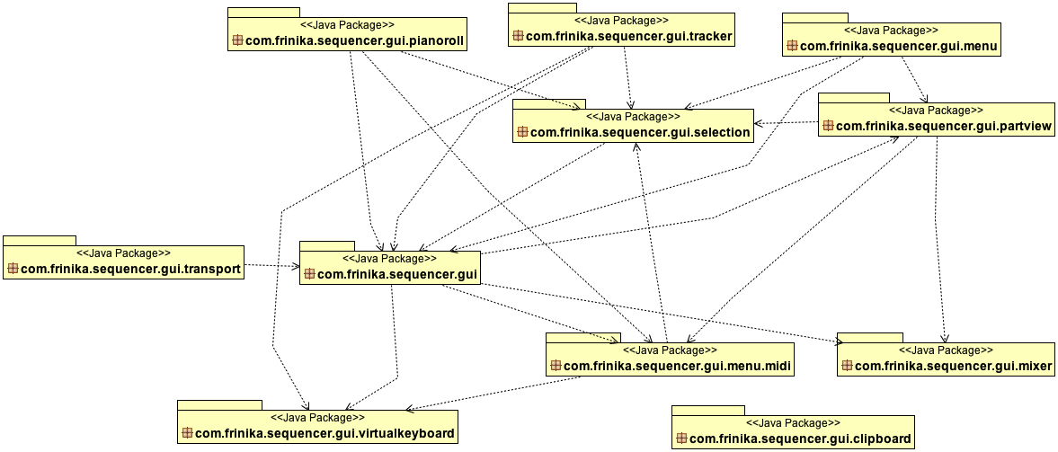
Figure 2: Actual Frinika Architecture, represented by its Package Diagram.
com.frinika.sequence.gui is the root package for the GUI component and all other packages have it as prefix, so they will be referred only by its last denomination, for example, com.frinika.sequencer.gui.traker is referred in this document only as tracker.
Some actual packages can be mapped to concepts defined in the Domain Diagram. For example, pianoroll and tracker are used to edit music tracks with the help of virtualkeyboard, therefore they are subtypes of editors and can be mapped to the concept “Editor” in the Domain Diagram. Other direct mappings can be identified: package mixer maps to the concept Mixer, and packages partview and menu.midi together are mapped to the concept Track.
transport represents the player controls (play, pause, stop, rewind, fast forward) and are actions taken within the Music concept from figure 1. Finally, the package menu loosely represents the concept Project in the Domain Diagram.
However, some packages are not represented at all in figure 1. It is the case of selection, which represents the user selection, of notes or time interval of a music track. Also, clipboard represents notes selected and copied by the user, to be pasted somewhere else.
In order to provide a more detailed evaluation of part of Frinika GUI architecture, figures 3 and 4 present the Class Diagrams for two key packages: pianoroll and tracker, both used to edit music tracks.
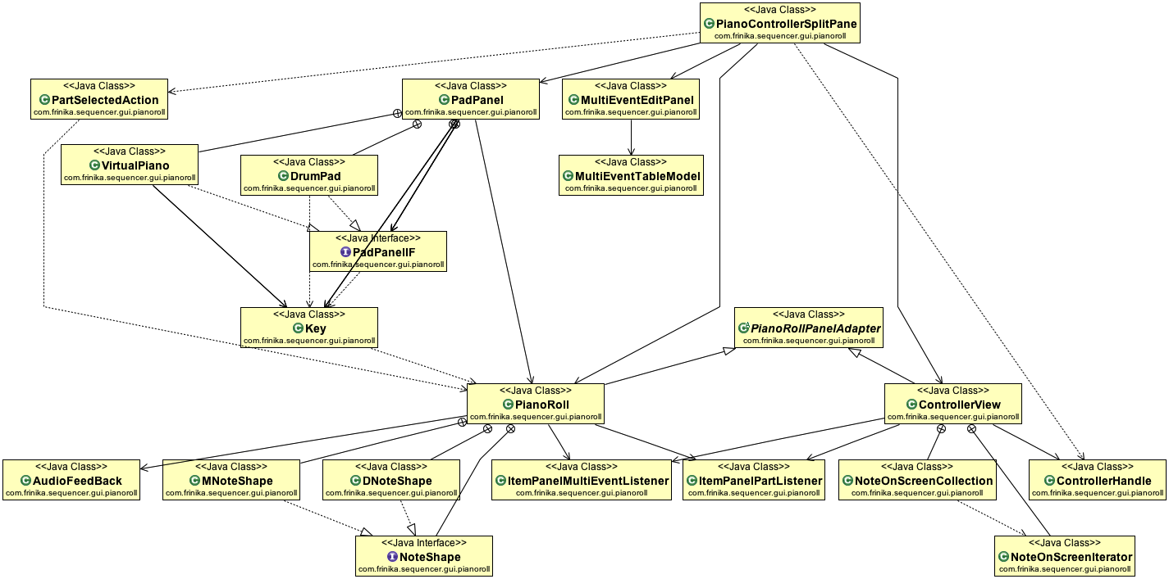
Figure 3: Class Diagram of com.frinika.sequencer.gui.pianoroll

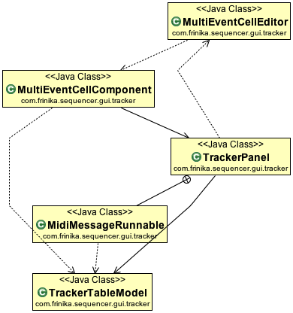
Figure 4: Class Diagram for com.frinika.sequencer.gui.traker
1- From figure 3, the class VirtualPiano represents piano-like keys where the user (musician) can compose new tracks. It makes use of white and black keys, represented by the class Key. Their relationship is partially depicted next.

The class VirtualPiano has attribute variables of Key vectors, one for while keys and one for black keys, and the constructor Key() is called.

class VirtualPiano implements PadPanelIF {
…
Vector<Key> blackKeys = new Vector<Key>();
Vector<Key> whiteKeys = new Vector<Key>();
…
public void resizeKeys() {
blackKeys.clear();
whiteKeys.clear();

…
int whiteIDs[] = { 0, 2, 4, 5, 7, 9, 11 };
…

// / You will be the size I want . . . .
// setSize(new Dimension(keyDepth, yBot));
// // setMinimumSize(new Dimension(keyDepth, yBot));
// setPreferredSize(new Dimension(keyDepth, yBot));
// setMaximumSize(new Dimension(keyDepth, 20000));
for (int i = 0, y = 0; i < nOctave; i++) {
for (int j = 0; j < 7; j++, y += whiteKeyWidth) {
int keyNum = i * 12 + whiteIDs[j];
if (keyNum >= nNote)
break;
whiteKeys.add(new Key(0, yBot - y, keyDepth, whiteKeyWidth,
keyNum));
}
}
}
…
}
…
}

And finally, the class Key implement the previously invoked methods:
public class Key extends Rectangle {
…
public Key(int x, int y, int width, int height, int num) {
super(x, y, width, height);
kNum = num;
}
…
}

2- In figure 3, the classes PianoControllerSplitPane and PartSelectedAction reflect the action of when the user selects a part of the piano roll. The former class calls the method actionPerformed() which in turn focuses on the selected part of the piano roll pane.
3- In figure 4, the TrackerPanel calls methods in the TrackerTableModel class that return values for each track such as velocity, edit duration, ticks per row (track), number of rows (tracks) and the current playing row (track). Following is the class code TrackerTableModel with selected attributes and methods of interest:
public class TrackerTableModel extends AbstractTableModel implements EditHistoryListener {
int editVelocity = 100;
double editDuration = 1.0;
double ticksPerRow;
int beatCount = 0;
FrinikaSequencer sequencer;
FrinikaSequence sequence;

public TrackerTableModel(ProjectFrame frame) {
this.frame = frame;
ProjectContainer project = frame.getProjectContainer();
this.sequence = project.getSequence();
this.ticksPerRow = sequence.getResolution() / 4.0; // Default 1/4th notes
this.sequencer = project.getSequencer();
timeUtils = new TimeUtils(project);

project.getEditHistoryContainer().addEditHistoryListener(this);
}

public int getEditVelocity() {
return editVelocity;
}
public double getEditDuration() {
return editDuration;
}
public int getTicksPerRow() {
return (int)(sequence.getResolution() / ticksPerRow);
}
public int getRowCount() {
return (int)((beatCount * sequence.getResolution()) / ticksPerRow);
}
public final int getPlayingRow()
{
return getRowForTick(sequencer.getTickPosition());
}
}

The following reverse engineering tools were used:
- Diver: used to identify the classes used in specific use cases. Even though this information contributed a lot to the understanding of Frinika’s architecture and implementation, it was decided that instead of focusing on use cases, we would focus our efforts on all classes within the packages pianoroll and tracker.
- Object Aid: used to automatically generate package and class diagrams.
- ModelGoon: used to automatically generate interaction diagrams as well as system sequence diagrams for understandability.

Code Smell and Possible Refactoring
This section describes the code smells and related refactorings identified in the packages pianoroll and tracker.
Some Code Smells were identified in Frinika GUI implementation, in different classes:
- PianoRoll
  - Code smell: Large Class (34 methods versus average of ~6.1 methods/class)
  - Code smell: paintImageImpl is a Long Method (180 LOC versus an average of ~8.2 LOC per method; McCabe's Cyclomatic Complexity = 45!!!)
  - Code smell: Switch Statements
- PadPanel
  - Code smell: Primitive Obsession (attributes ON and OFF have integers 0 and 1 assigned to them)
- Key
  - Code smell: Divergent Change (it performs tasks of presentation (GUI) and domain layers)
- ControllerView
  - Code smell: Large Class (33 methods versus average of ~6.1 methods/class)

Therefore, in order to improve cohesion, the following Refactorings can be performed:
PianoRoll
Refactoring: Extract Class, reducing the size and responsibilities of this class (1a).

Key
Refactoring: Separate Domain from Presentation, tackling the issue of Divergent Change (3a).

ControllerView
Refactoring: Extract Class, reducing the size and responsibilities of this class (4a).

Additionally, to improve understandability of the source code, the following refactorings are suggested:

PadPanel
Refactoring: Replace Type Code with Class, replacing the attributes ON an OFF with NoteStatus.ON and NoteStatus.OFF; and replacing Color(0xffeeee), etc with Color.WHITE, Color.BLACK, etc. (2a).

PianoRoll
Refactoring: Extract Method. (1b).
Refactoring: Replace Conditional with Polymorphism, Extract Method and maybe Move Method to a domain class, to be evaluated during refactoring implementation. (1c).

As an example, the Code Smell 1c (Switch Statements) on class VirtualPiano are depicted next.

public class PianoRoll extends PianoRollPanelAdapter {
...
public void dragTo(Point p) {

...
switch (dragMode) {
case OVER_ITEM_MIDDLE:
long tick = ev.getStartTick() + dtick;
int pitch = ((NoteEvent) ev).getNote() + dpitch;
dt = Math.min(dt, tick);
ev.setStartTick(tick);
ev.setNote(pitch);
break;
case OVER_ITEM_RIGHT:
long dur = ev.getDuration() + dtick;
dur = Math.max(1, dur);
ev.setDuration(dur);
break;
case OVER_ITEM_LEFT:
dur = ev.getDuration() - dtick;
long st = ev.getStartTick() + dtick;
dur = Math.max(1, dur);
ev.setDuration(dur);
ev.setStartTick(st);
break;
default:
System.err.println(" unknown dragmode " + dragMode);
}
...
}
...
}

Other re-factorings are listed below.

1 – PadPanel
Code-Smell: Large Class
Refactoring: Extract Class, Extract interface.
Solution: PadPanel seems to have a lot of work being done under the hood, it possesses couple of public classes & interface that could well be extracted outside the class to simplify the responsibilities of the class and segregate the distinct functionalities.
Below is a snippet of the class

public class PadPanel extends JPanel implements MouseListener,AdjustmentListener, SelectionListener<Part> {
....
interface PadPanelIF {
void resizeKeys();
void paintComponent(Graphics g);
Key getKey(Point point);
}

class DrumPad implements PadPanelIF {
private static final long serialVersionUID = 1L;
int noteItemHeight;

public void resizeKeys() {
noteItemHeight = Layout.getNoteItemHeight();

yBot = (nNote + 1) * noteItemHeight;
int y = 0;
for (int j = 0; j < nNote; j++, y += noteItemHeight) {
keys[j] = createkey(0, yBot - y, keyDepth, noteItemHeight, j);
}
validate();
}
.....
}

class VirtualPiano implements PadPanelIF {
Vector<Key> blackKeys = new Vector<Key>();
Vector<Key> whiteKeys = new Vector<Key>();
final int nWhiteNote = (nNote / 12) * 7 + 5;
final int nOctave = nNote / 12 + 1;
int whiteKeyWidth, blackKeyDepth = (int) (keyDepth * .6);
int blackWhiteGap;
int noteItemHeight;

public void resizeKeys() {
....
}
.... }

2 - TrackerPanel

Code-Smell: Duplicated Code
Refactoring: Consolidate Conditional Expression , Extract Method

solution: I would group all the if-clauses together using the 'or' operator and then extract them into a method, the method shall be given the name that depicts the operation i.e: IsColumnModelIndexSelected(int index) which returns a boolean.

Code snippet:

public class TrackerPanel extends JPanel implements SelectionListener<Part>,SongPositionListener {

.....

public boolean isColumnSelected(int column) {
if(column == 0) return false;

int c = column - 1;
c = c - c % 4;

if(columnModel.getSelectionModel().isSelectedIndex(c+1)) return true; if(columnModel.getSelectionModel().isSelectedIndex(c+2)) return true;
if(columnModel.getSelectionModel().isSelectedIndex(c+3)) return true;
if(columnModel.getSelectionModel().isSelectedIndex(c+4)) return true;

return false;
//return columnModel.getSelectionModel().isSelectedIndex(column);
}
...
}

Class Diagram after Refactoring
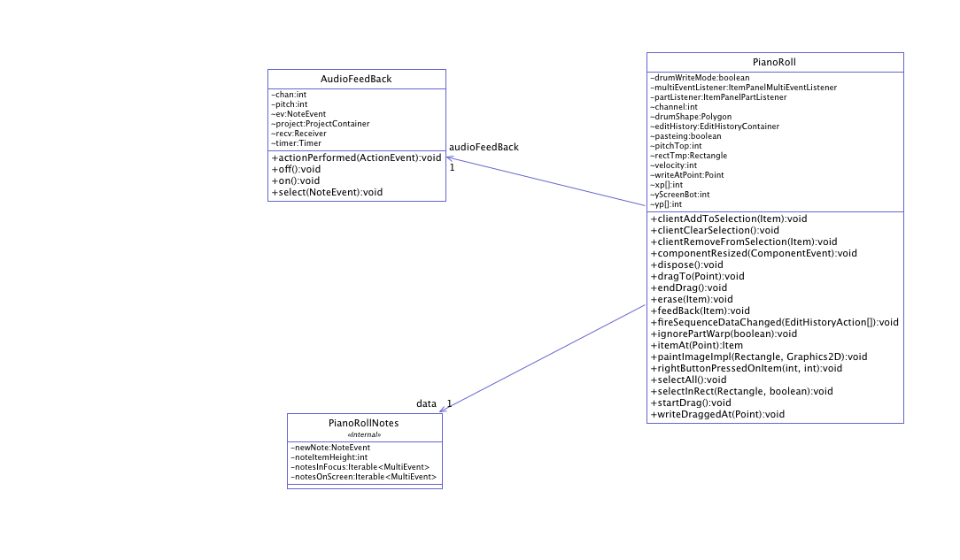
To address the code smell of large class in PianoRoll, the extract class refactoring has been applied (PianoRollNotes class extracted). This in turn reduces the size and responsibilities of this class. Due to the large package diagram, the class diagram of the PianoRoll and the related classes has only been extracted.

Figure 5: Class Diagram for PianoRoll and PianoRollNotes after refactoring.

